Quiz paper
1. Please write down down the names of the following organic compounds
i. C₄H₈
ii. HCOOH
iii. C₂H₅OH
iv. CH₂CHCH₂CH₃
2. Please write down displayed formulae for these organic compounds
i. propan-1-ol, ii. propan-2-ol,

iii. CH₃CH₂COOH iv. But-2-ene

3. Which polymers or types of polymer are synthetic? （ ）
1carbohydrates 2nylon 3proteins 4Terylene
A.1 and 3 B.1 and 4 C.2 and 3 D.2 and 4

4. Which substances can be obtained by cracking hydrocarbons? （ ）
A ethanol and ethene
B ethanol and hydrogen
C ethene and hydrogen
D ethene and poly(ethene)

5. In which reaction could one of the products belong to the same homologous series as the organic reactant? （ ）
A addition of steam to ethene
B combustion of an alkane
C cracking of an alkane
D polymerisation of ethene
6. The diagram shows a reaction sequence.
Which row names the processes X, Y and Z? （ ）
 | X | Y | Z
A | cracking | fermentation | respiration
B | cracking | hydration | combustion
C | distillation | fermentation | respiration
D | distillation | hydration | combustion

7. Part of a polyester chain is shown. This polyester is made from one monomer.
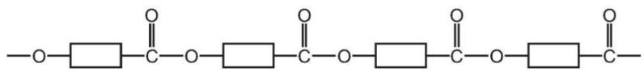
a. On the diagram draw a ring around one unit of the polymer that is repeated. [1]
b. Name the type of polymerisation that produces polyesters.
.........................................................................................................................[1]
c. Complete the diagram to show the structure of the monomer used to produce this polyester. Show all of the atoms and all of the bonds in the functional groups.
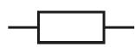
d.A polyamide is made from the two monomers shown.
Complete the diagram to show a section of the polyamide made from the two monomers. Show all of the atoms and all of the bonds in the linkages.

6. There are three functional groups in compound A.
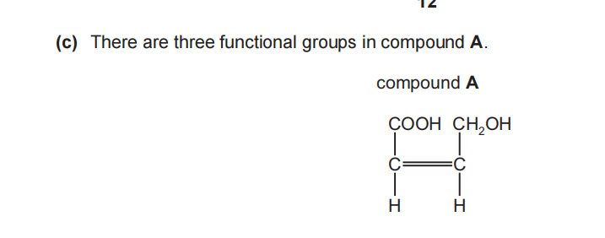
Compound A can be used as a single monomer to produce two different polymers.
1)Draw one repeat unit of the addition polymer formed from compound A.

2)What type of condensation polymer is formed from compound A?
.........................................................................................................................[1]
3)Molecules A and B can form condensation polymers.
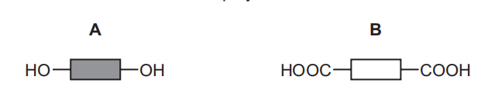
(a) Each molecule has two identical functional groups.
(i) Name the functional group in B.
.........................................................................................................................[1]
(ii)Draw the part of the structure of the synthetic polymer that would form when two molecules of A and two molecules of B combine. Show all of the bonds in the linkages.

[3]
(iii)Name the other product formed when molecules of A and B undergo polymerisation.
.........................................................................................................................[1]

